**SECURE CODING**

**LAB – 6**

* G JAY VENKAT
* 18BCN7112

1. Write a python script to get all the file names in the current directory​

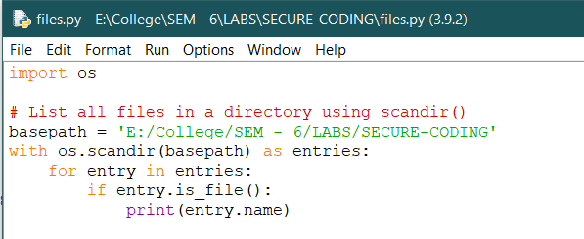

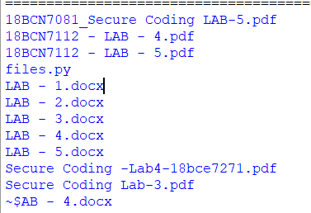

1. Write a python script to get all the directory names in the current directory​

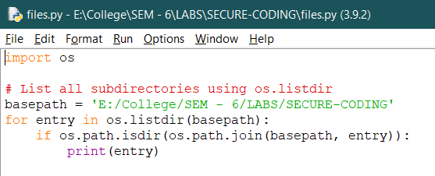

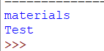

1. Write a python script to get all the directory and subdirectory names in the current directory​

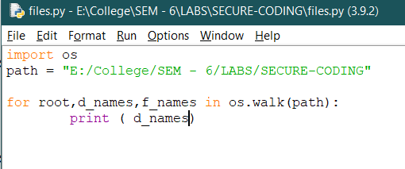

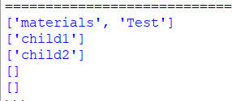

1. Write a python script to get all the file name, directory and all the subdirectory names (recursively) in the current directory​

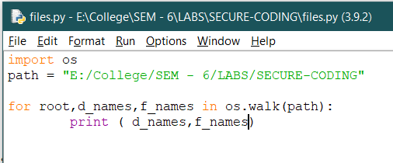

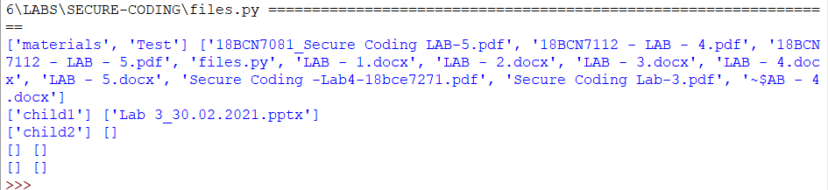

1. Write a python script to get all the file name, directory and all the subdirectory names (recursively) in the current drive and write it to a text file. ​

Create a text file named output.txt in the below directory or your own directory.

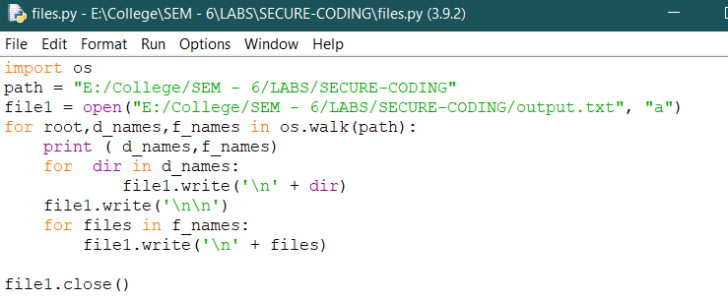

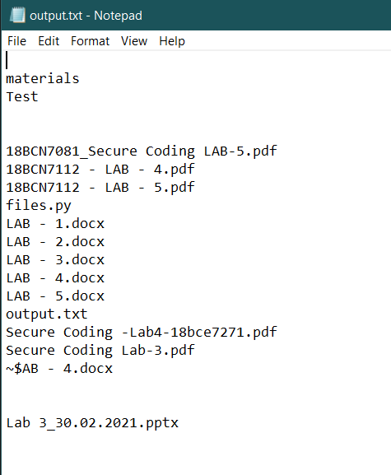

1. Write a python script which creates four new files in the current directory using Powershell.

